To protect the integrity of the water supply Southern Water specifies the standard of fittings to be used for service connections in accordance with the statutory requirements of the Water Industry Act 1991. A failure to use approved fittings may result in a delay in a connection being made or a connection being refused.
For further information please see the guidance provided below…

1 The Water Fittings Regulations require that water fittings are Reg 4 Complaint – ie of an appropriate quality and standard, suitable for the circumstances in which will be used and installed in compliance with any applicable requirements given in schedule 2 of the Regulations and the requirements of Southern Water. (Check QR link for reg 4)

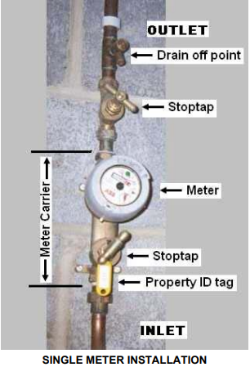
2 The meter carrier will be of a gunmetal or similar approved material (not plastic), complete with integral stoptap, both the inlet and outlet must have 3/4" BSP threaded ends. The meter carrier is also to have an in-built single check valve and the stoptap must be a ‘†Screwdown type ie a BS1010 design’.

3. A drain valve and a stop tap are to be fitted immediately after (downstream of) the meter carrier.

4. Each flat will have its own meter, there will be no shared supply

5. All meters once fitted must have a tag to accurately identify each property flat number

6. The meter carrier must be correctly secured to a backboard.

7. The Builder/Developer must ensure that the owner of each flat is shown the location of their meter.

8. Access for meter maintenance and meter reading will be required 24 hours a day / 365 days a year.

10 Southern Water will not carry any special keys to open doors to gain entry to premises or meter cupboards. Any doors that need secure access must be fitted with coded pads and the codes provided to Southern Water. The meter cupboard(s) must not be
lockable.

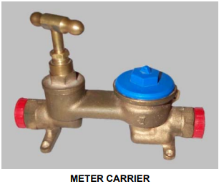
11 All future maintenance and responsibility for pipework within the grounds of the property and internal pipework within the building(s), rests with the owner(s) of the property. This includes the meter carriers, but not the meters.

12 The meters will remain the responsibility of Southern Water and must not be removed or
tampered with by others.

13 Water and electrical apparatus must not be installed in close proximity or within the same cupboard

Notes:
The meters will only be installed on carriers that meet our requirements. (These can be supplied by Southern Water if required and recharged via the job estimate or purchased from an independent supplier).
†Screwdown type stop valves similar to the BS1010 design are required on supplies above 25mm since, this is because ball valves are capable of being opened rapidly which on a larger supply can result in pressure surges and damage to water systems.

